**MODULE-5**

**IMPORTANT IRON DEPOSITS IN INDIA**.

* In MP & Chhattisgarh the ores are massive and deposits are associated with the Banded Hematite Quartzite (Dharwar). Bailadila range of hills have 64.75-69.41%Fe content.
* In Orissa and Jharkhand the iron ore are associated with both the Banded Hematite Quartzite (BHQ) and Banded hematite Jasper. Bonai range of hills have 55-63%Fe content.
* In Karnataka, there are two main types of iron deposits, the lateritoid hematitic iron ore concentrations with minor limonite and goethite and magnetite ore deposits. In the Bellary district high grade hematite ores occur in Banded Hematite Quartzite.
* The richest iron ore deposits in Goa are found between Advapale and Madei river. Near Nuem and Cananquinim Banded Hematite Magnetite Quartzite occur as lensoid bodies while the manganese bearing cherts and quartzites occur in narrow bands.

**Iron Ore Reserves of India**

|  |  |
| --- | --- |
| **Region** | **Hematite** |
| Eastern Region (Orissa, Jharkhand) | 6000 |
| Central (Chhattisgarh, M.P.) | 2000 |
| Southern (Karnataka: Bellary - Hospet) | 1000 |
| Western (Goa) | 1000 |
| Total | 10000 |
|  | **Magnetite** |
| Southern (Karnataka, Andhra Pradesh) | 3200 |
| Western Goa) | 200 |
| Total | 3400 |
| **Country Total** | 13400 |

**AGGLOMERATION:**

The fines that are produced in the mineral processing plants cannot be used directly in the blast furnace. These iron ore fines cannot be used directly in the blast furnace.

They causes following threats:-

1. The fines decrease the bed permeability and hinder the bed reaction.

2. The fines leave the blast furnace with the flue gas, which brings down the blast furnace efficiency.

But the extraction of metal from these fines can be possible by forming in lumpy forms. These lumpy forms for can be handled easily and directly be used as charge for the blast furnace. These lumpy forms are called agglomerates and the process is called agglomeration. There are three main types of agglomeration process:- Pelletization, sintering and briquetting.

**SINTERING**

**Introduction**

* During the I/O mining and beneficiation process, the percentage of I/O fines produced is high.
* These I/O fines produced can’t be used in blast furnace directly.
* In order to use these in blast furnace, I/O fines are agglomerated.
* Hence, sintering is done.
* Sintering is the process for agglomeration of fine mineral particles into a Porous and lumpy mass by incipient fusion caused by heat produced by combustion of solid fuel within the mass itself.

**Raw Material used in Sintering plant**

* Iron ore fines
* Lime stone fines
* Dolomite fines/ dunite fines / pyroxinite fines
* Coke breeze fines
* Lime dust

**Sintering Plant equipments**

* Continuous Sintering machine
* Mixing drums
* Wind box
* Furnace
* Exhaust fan
* Sinter crusher
* Screens

**Blending of raw material**

Following approximate charge proportion will be required to make one tonne of sinter-

* Ore fines: 815 kg
* Coke: 87 kg
* Lime stone: 317 kg
* Dolomite: 38 kg
* Lime dust: 40 kg

**Preparation of charge mix**

* Crushing of fluxes, solid fuels, proper sizing of them
* Lime stone & Dolomite fines should be crushed to obtain 90% minimum(-3mm fraction).
* Normally for crushing Roll crushers is used.
* Mixing with Ore fines in a certain ratio to prepare base mix
* Finely crushed coke and fluxes are mixed with ore fines(called as a BASE MIX) in required proportion in balling/nodulising drum where atomized water is added .
* Purpose of balling/nodulising drum are homogenizing of base mix and formation of balls.
* Base mix is then loaded on moving sinter machine pallets through belt conveyors and segregation plates
* purpose of segregation plate is to segregate the base mix such that coarser particles falls in the bottom of sinter machine, medium particles in middle portion and smaller particles at the top by rolling effect.
* Before loading base mix on sinter machine, a layer of return sinter(namely hearth layer) is loaded on pallets forming the bottom most portion of the charge just above the pallet grates. This hearth layers helps in preventing burning of grate bars apart from getting optimum under grate suction.

**Sintering Process**

* Sintering of fines by suction method consists of the mixing of fines with finely crushed coke as fuel.
* Ignition of the fuel proceeds on the surface of charge by ignition furnace.
* The gases used in ignition furnace are mainly coke oven gas and blast furnace gases.
* combustion is continued due to suction of air through the layers of the charge by means of Exhausters

**Sintering process can be divided into six distinct zones:**

1. Zone of Cold Sinter (60 to 100 degree Celsius)

2. Zone of hot Sinter (100 to 1000 degree Celsius)

3. Zone of intensive combustion of fuel (1100 to 1350 degree Celsius)

4. Heating zone (1000 to 700 degree Celsius)

5. Zone of Pre-heating of charge (700 to 60 degree Celsius)

6. Zone of Re-condensation of moisture (60 to 30 degree Celsius)

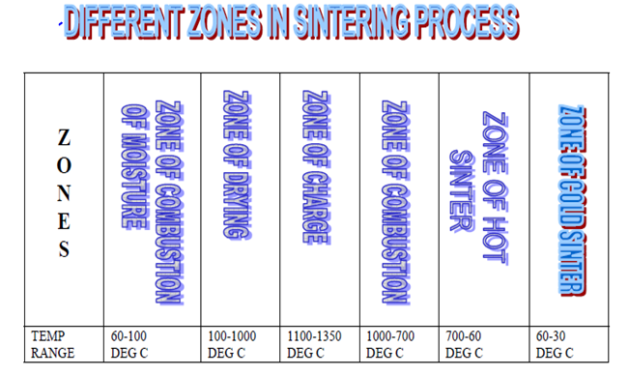

**Chemical reactions in sintering process:**

* 1. C+O2---CO2 + 4220calories
* 2. CO2 + C --- 2CO + 53140 calories
* 3. 3Fe2O3+ CO ---- 2Fe3O4 + CO2 + 8870 calories
* 4. Fe3O4 + CO ---- 3FeO + CO2 - 4990 calories

**Factors affecting sintering process:**

**1. Quality of Input raw materials**

**a. Quality of Iron ore fines:**

* Increase in +10mm fraction will result in weak sinter & low productivity .
* Increase in –1mm fraction will decrease bed permeability resulting in low productivity .
* Increase in % of Alumina increases RDI(Reduction Degradation Index) resulting in generation of –5mm fraction.

**b. Quality of Flux:**

-3mm fraction should be 90% minimum

***c.* Quality of Coke:**

-3mm fraction should be 90% minimum

+5mm fraction should be nil.(Increase in 5mm fraction decreases the productivity).

**2.Moisture content:**

* Addition of water in base mix plays an important role in sinter bed permeability.
* Ideally 6 to 7% of total base mix of water are used.
* Higher % of water results in low permeability & less sintering speed.
* Less % of water results in less balling, hence less permeability, resulting in low productivity.

**3. Ignition furnace temperature:**

* Higher hearth temperature results in fusing of sinter at top layer. This reduces the bed permeability, hence low productivity.
* Low heart temperature results in improper ignition.

**4. Coke rate:**

* It is normally 6% of total charge.
* Higher coke rate will fuse the top layer, thereby decreases the bed permeability. Sticker formation will increase.
* Low coke rate will result in incomplete sintering.

**Advantages of using Sinter:**

* Agglomeration of fines into hard, strong and irregular porous lumps, which gives better bed permeability.
* Utilizes the solid wastes of steel industry.
* To utilize the coke breeze generated in coke screening as fuel otherwise has no metallurgical use
* As the calcinations of flux takes place in sinter strand, super-fluxing saves much more coke in the furnace.
* Increase of sinter percentage in Blast Furnace burden, increases the permeability, hence reduction and heating rate of burden increases, so the productivity also increases.

**PELLETIZING**

**OBJECTIVE**

* Pelletization study to agglomerate concentrate of low grade iron ore fines using disc & drum pelletiser.
* Analyzing effect of different variables such as moisture content, Binding agent, inclination, time and speed on pellet formation & growth.

**INTRODUCTION**

* To Utilize finely devided concentrates from beneficiation plants.
* To Prepare the pellets of suitable size and shape from which desired constituent can be extracted at a subsequent stage.
* To form a definite shape of product from fines.
* To eliminate problems of dust and waste disposal.
* To improve flow characteristics of powdered materials.
* To improve bulk handling characteristics for transportation and storage**.**

**FLOW SHEET**

**THE PELLETIZATION PROCESS**

* Feed preparation
* Pelletization of green or wet balls from dry fines.
* Drying of the green pellets to prepare it for induration.
* Firing of dried pellet at high temperature, to bring about enhanced strength
* Pellet quality evaluation.

**GREEN PELLETIZATION**

* Bonding mechanism
* Growth mechanism in green pelletization
* Green pelletizing equipment
* Factors affecting green pellet quality

**INDUSTRIAL PROCESS OF PELLETIZING PLANT**

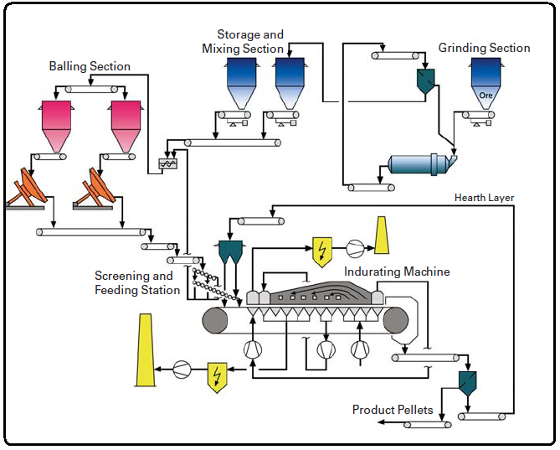**GRANULE SEGREGATION ON A DISC PELLETIZER**

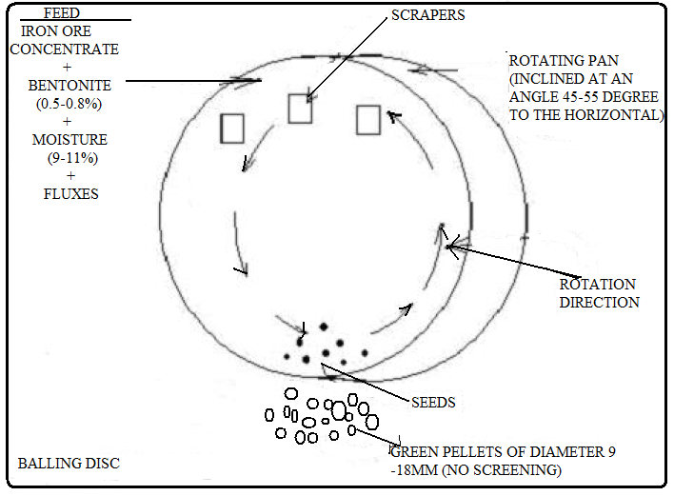

**ADVANTAGES OF USING DISC PELLETIZER**

|  |  |  |
| --- | --- | --- |
| **ITEM** | **DISC** | **DRUM** |
| extent of mixing | Acts nearly as a perfect mixer | Not the same extent as disc |
| Classification of disc | Act as a classifier | Not like the disc |
| Nucleation | In the wet zone | In the wet zone |
| Growth | Mainly by layering | Mainly by assimilation |
| Space requirement and capital cost | 30% less | More than that for equivalent capacity disc |
| Circulation load | Less and hence less power nearly 50% of feed rate | Both more 50-100%of feed rate |
| Specific production rate | 20 T/sq.mt of pelletizer area | 7-12%of pelletizer area |
| Flexibility of operation | More flexible | Less flexible |

**FACTORS AFFECTING GREEN PELLETIZATION**

* Moisture content of the feed
* Type of binder and its content
* Mechanical forces applied by pelletizer
* Pelletization time
* Granulometric properties

i) Grain size

ii) Feed size distribution

**INDURATION OF GREEN PELLETS**

For major types of indurating process:

Shaft furnaces Steel belt

Straight travelling grate Rotary grate kiln

**PELLET QUALITY EVALUATION METHOD**

* Drop test
* Green compressive strength
* Dry compressive strength
* Porosity and pore saturation
* Plastic deformation
* Thermal spelling

**BRIQUETTING AND THEIR APPLICATIONS**

The agglomeration process in which lumps are made by compacting the iron bearing fines and dust with addition of binder and also de-airing these mixtures inside the vacuum chamber of the briquetting machine.

So, briquetting process is developed to meet these demands. This process aims at recycle and reuse of the low grade iron ore and plant fines. This product can be used as a feed to blast furnace operation. This process has several benefits. It is mostly aims to saving of energy and decrease the environmental pollution. The demands for briquetting are increasing as they have uniform size, shape, weight and composition which complete the requirement for production process.

The mechanical properties of these briquettes are greatly affected by briquetting pressure, distribution of particle size and time of compressing. These parameters depend upon the composition of the briquettes.

To get briquettes of desired quality, we have to use binders. These binders hold the particles of the briquette together. There are various types of binders such as Portland cement, asphalt, pitch, sodium silicate, clay, plastics, sulphur liquor, lime, bentonite, tar, molasses, etc.

**Application**

Direct reduction plants uses Hot Briquetted Iron and Direct Reduced Iron to make different materials.

**Advantages of Hot Briquetted Iron over Direct Reduced Iron:-**

* The loss of metallization is less in HBI even after longer time of storage.
* HBI can be stored at open air and it doesn’t cause any problems.
* The chance for overheating minimizes during storage and transport.
* The fine that is produced during handling is less.
* High apparent density and Bulk density.
* Saturation of moisture is lowered.
* These are relatively small and has uniform product size which helps in easy charging in blast furnace.

Due to these advantages, most of the merchant reduction plants are going for planning and construction to make HBI.